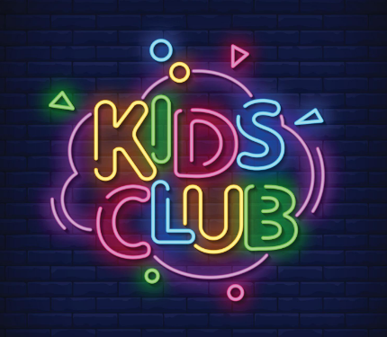

Kids’ Club 2024-2025

Kids’ Club (before and after care) is offered at New Morning School as a convenience to our families that need childcare beyond school hours.

Registration:
- You must enroll in Kids’ Club at least 1 week in advance of your child's start date.
- There is no additional registration fee. Registration is included with your Enrollment registration fee.
- Kids’ Club for Preschool Full-Time Care (Attends 5 Full Days per week) is included in tuition.
- AM Only Preschool students are eligible for AM Care only.
- Full Day, Part-Time students are eligible for AM & PM Care, at an extra cost to regular tuition.

Hours:
Before Care Hours: 7:00am-8:15am
After Care Hours: 3:15pm-6:00pm
Specified Non-School Day Care: AM session 7am-12:30pm Full Day session 7am-6pm

There are two ways to opt-in to Kids’ Club: Contracted or Drop-In Care

Contracted Care:
- Fixed Number of Days each week
- Choose desired number of days of care per week, in advance, when registering
- Pay in full in advance OR pay a fixed monthly fee based on your plan
- Minimum 2 days per week

AM Only: $10 per day
PM Only: $17 per day
AM & PM: $23 per day
Non-School Full Days: $23 AM or $46 FULL Day

*10% Discount for siblings

Drop-In Care:
- Flexible scheduling
- No minimum number of days required
- Pay as you go, invoiced at the end of the month

AM: $15 per day
PM: $25 per day
Non-School Full Days: $40 AM or $80 FULL day (must sign up 1 week in advance, to allow for staffing)

